**PIZZA SALES SQL QUERIES**

**A. KPI’s**

**1. Total Revenue**

SELECT SUM(total_price) AS Total_Revenue FROM pizza_sales;

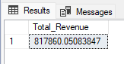

**2.Average Order Value**

SELECT SUM(total_price) / COUNT(DISTINCT order_id) AS Avg_Order_Value FROM pizza_sales;

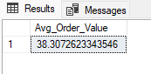

**3. Total Pizza Sold**

SELECT SUM(quantity) AS Total_pizza_sold FROM pizza_sales;

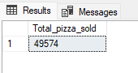

**4. Total Orders**

SELECT COUNT(DISTINCT order_id) AS Total_Orders FROM pizza_sales;

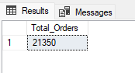

**5. Average pizza per order**

SELECT CAST(SUM(quantity) AS DECIMAL(10,2)) /

CAST(COUNT(DISTINCT order_id) AS DECIMAL(10,2)) AS Avg_pizza_per_order FROM pizza_sales;

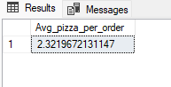

**Hourly Trend for Total Pizza Sold**

SELECT DATEPART(HOUR, order_time) AS order_hour, SUM(quantity) AS Total_pizza_sold

FROM pizza_sales

GROUP BY DATEPART(HOUR, order_time)

ORDER BY DATEPART(HOUR, order_time);

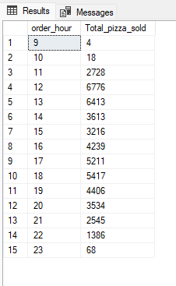

**Weekly Trend for Total Orders**

SELECT DATEPART(ISO_WEEK, order_date) AS week_number, YEAR(order_date) AS order_year,

COUNT(DISTINCT order_id) AS Total_orders

FROM pizza_sales

GROUP BY DATEPART(ISO_WEEK, order_date), YEAR(order_date)

ORDER BY DATEPART(ISO_WEEK, order_date), YEAR(order_date);

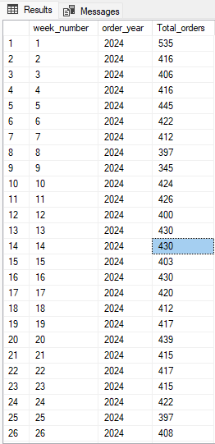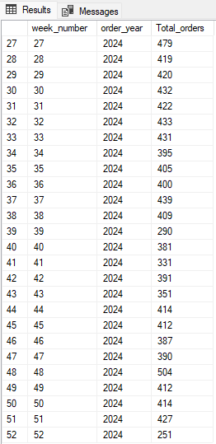

**Percentage of Sales by Pizza Category**

SELECT pizza_category, CAST(SUM(total_price) AS DECIMAL(10,2)) AS Total_Revenue,

CAST(SUM(total_price) * 100 /

(SELECT SUM(total_price) FROM pizza_sales) AS DECIMAL(10,2)) AS PCT

FROM pizza_sales

GROUP BY pizza_category;

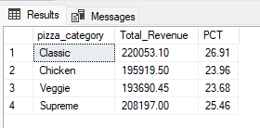

**Percentage of sales by pizza size**

SELECT pizza_size, CAST(SUM(total_price) AS DECIMAL(10,2)) AS Total_Sales, CAST(SUM(total_price) * 100 /

(SELECT SUM(total_price) FROM pizza_sales) AS DECIMAL(10,2)) AS PCT

FROM pizza_sales

GROUP BY pizza_size

ORDER BY PCT DESC;

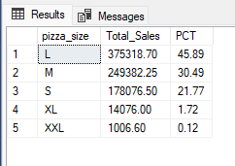

**Top 5 Best Sellers by revenue**

SELECT TOP 5 pizza_name, SUM(total_price) AS Total_Revenue

FROM pizza_sales

GROUP BY pizza_name

ORDER BY Total_Revenue DESC;

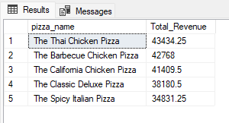

**Bottom 5 sellers by revenue**

SELECT TOP 5 pizza_name, SUM(total_price) AS Total_Revenue

FROM pizza_sales

GROUP BY pizza_name

ORDER BY Total_Revenue ASC;

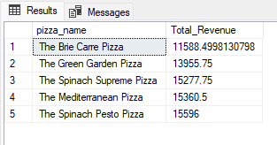

**Top 5 Best Sellers by quantity**

SELECT TOP 5 pizza_name, SUM(quantity) AS Total_Quantity

FROM pizza_sales

GROUP BY pizza_name

ORDER BY Total_Quantity DESC;

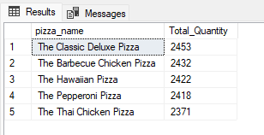

**Bottom 5 Best Sellers by quantity**

SELECT TOP 5 pizza_name, SUM(quantity) AS Total_Quantity

FROM pizza_sales

GROUP BY pizza_name

ORDER BY Total_Quantity ASC;

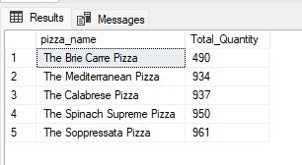

**Top 5 Best Sellers by order**

SELECT TOP 5 pizza_name, COUNT(DISTINCT order_id) AS Total_Orders

FROM pizza_sales

GROUP BY pizza_name

ORDER BY Total_Orders DESC;

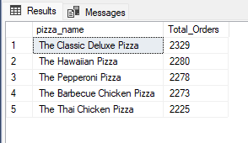

**Bottom 5 Best Sellers by order**

SELECT TOP 5 pizza_name, COUNT(DISTINCT order_id) AS Total_Orders

FROM pizza_sales

GROUP BY pizza_name

ORDER BY Total_Orders ASC;

